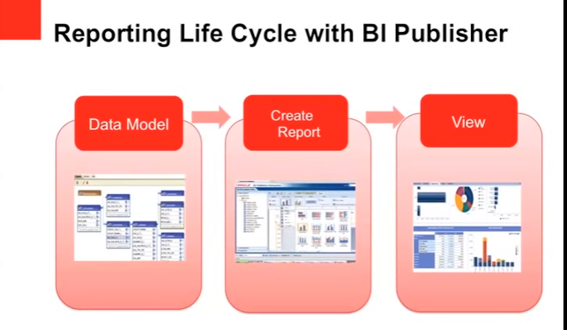

It is a reporting tool for generating the reports. More than tool it is an engine that can be integrated with systems supporting the business.

**What is the difference between xml publisher and BI Publisher?**

Name is the difference, initially it was released on the name of xml publisher( the initial patchset), later on they have added more features and called it Business Intelligence Publisher. In BI by default we have integration with Datadefinitions in R12 instance. Both these names can be used interchangeably.

**What are the various components required for developing a BI publisher report?**

Data Template, Layout template and the integration with Concurrent Manager.

**What is a datatemplate?**

Datatemplate is an xml structure which contains the queries to be run against the database so that desired output in xml format is generated, this generated xml output is then applied on to the layout template for the final output

**What are the various sections in the data template?**

* Parameter section
* [Trigger Section](https://tekslate.com/apex-triggers-introduction/)
* Sql statement section
* Data Structure section
* Lexical Section

**What is a layout template?**

Layout template defines how the user views the output, basically it can be developed using Microsoft word document in rft (rich text format) or [Adobe](https://tekslate.com/adobe-cq5-interview-questions-and-answers/) pdf format. The data output in xml format (from Data template) will be loaded in layout template at run time and the required final output file is generated.

**What are the output formats supported by layout template?**

xls, html, pdf, eText etc are supported based on the business need.

**Do you need to write multiple layout templates for each output type like html/pdf?**

No, only layout template will be created, BI Publisher generates desired output format when the request is run.

**Where do you register data and layout templates?**

Layout template will be registered under xml publisher administrator responsibility>Templates tab.  
Data template will be registered under xml publisher administrator responsibility> Data Definitions

**What is the required installation for using BI Pub report?**

BI Publisher desktop tool has to be installed. Using this tool you can preview or test the report before deploying the same on to the instance.

**How do you move your layout or data template across instances?**

xdoloader is the utility that will be used.

**What is the tool to map required data output and layout templates so that they can be tested in local machine?**

Template viewer will be used for the same.

**XDO template utility helper java classes - OAF pages**

**How to Upload RTF Template from Backend?**

Using XDO Loader, we can upload an RTF from Backend.

**How to repeat the Header of the template on each and every page of the output?**

Use <?@section: ?> in order to repeat that specific section in each page of the output.also to reset the page number.

**How many ways we can display images in a BI Publisher Report?**

It can be done in 5 ways

1. Direct Insertion into RTF Template
2. URL Reference
3. OA_MEDIA directory reference
4. Image from BLOB datatype from database
5. Using UI Beans

**How to do conditional formatting in XML Publisher?**

Conditional formatting in BI Publisher/XML Publisher can be done in these      some of the following ways :

1. **if statements:**

<?if:condition?>

your data

<?end if?>

2. **if then else statements**

<?xdofx:if element_condition

then output1

else output2

end if?>

**3. choose statements : for multiple conditions**

<?choose:?>

<?when:expression?>

<?otherwise?>

There are more ways for conditional formatting in addition to the above like column formatting ,row formatting etc

**What are the XML publisher tables?**

* PER_GB_XDO_TEMPLATES
* XDO_DS_DEFINITIONS_B
* XDO_DS_DEFINITIONS_TL
* XDO_DS_DEFINITIONS_VL
* XDO_LOBS
* XDO_TEMPLATES_B
* XDO_TEMPLATES_TL
* XDO_TEMPLATES_VL
* XDO_TEMPLATE_FIELDS
* XDO_TRANS_UNITS
* XDO_TRANS_UNIT_PROPS
* XDO_TRANS_UNIT_VALUES

**What is the difference between XML publisher and BI Publisher?**

* [XML](https://tekslate.com/steps-create-xml-source-qualifier-transformation-informatica/) Pub operates entirely within EBS and can only be used within EBS. BIP can be installed as a standalone version running off of several OC4J compliant engines, such as Application Server and Tomcat. BIP can be pointed anywhere, so you could do reports out of an OLTP or warehouse database, MSSQL and even within EBS. Licensing is already included in EBS, and the standalone costs whatever plus maintenance.

**‘IF ELSE’ condition in XML publisher**

* XML Publisher supports the common programming construct “if-then-else”. This is extremely useful when you need to test a condition and conditionally show a result. For example:

IF X=0 THEN

Y=2

ELSE

Y=3

END IF

You can also nest these statements as follows:

IF X=0 THEN

Y=2

ELSE

IF X=1 THEN

Y=10

ELSE Y=100

END IF

* Use the following syntax to construct an if-then-else statement in your RTF template:

|  |
| --- |
| <?xdofx:if element_condition then result1 else result2 end if?> |

* For example, the following statement tests the AMOUNT element value. If the value is greater than 1000, show the word “Higher”; if it is less than 1000, show the word “Lower”; if it is equal to 1000, show “Equal”:

|  |  |  |  |  |  |
| --- | --- | --- | --- | --- | --- |
| <?xdofx:if AMOUNT > 1000 then 'Higher' | | | | | |
| if AMOUNT < 1000 then 'Lower' | | | |  |  |
| Else | |  |  |  |  |
| 'Equal' |  |  |  |  |  |
| end if?> | | | | |  |

**SYSDATE in the header section dynamically when we run the report**

<?xdofx: sysdate(‘YYYY-MM-DD’)?>

**How to write a loop in rtf template design?**

<? For-each:G_invoice_no?>

     ……………………..<? End for each?>

**How to design sub templates in rtf layout?**

Using following tags..

  <? Template: template_name?>

          This is Last Page

                            <? End template?>

**How to call a header or footer?**

Using this tag

 <?call:header?> and <?call:footer?>

**How to break the page in specific condition?**

<?split-by-page-break:?>

**How to use section break?**

<?for-each@section:G_CUSTOMER(This is group name)?>

**How to create multi layouts in XMLP?**

<?choose:?>

          <?when:CF_CHOICE=’VENDOR’?>

            Your template….

          <?end when?>

                   <?when:CF_CHOICE=’INVOICE’?>

                   Your template….

                   <?end when?>

                        <?when:CF_CHOICE=’RECEIPT’?>

                         Your template….

                        <?end when?>

<?end choose?>

**How to display the images in XMLP?**

url:{'http://image location'}

                 For example, enter:

                   url:{'http://www.oracle.com/images/ora_log.gif'}

                      url:{'${OA_MEDIA}/image name'}

**How to pass the page numbers in rtf layout?**

<REPORT>

<PAGESTART>200<\PAGESTART>

....

</REPORT>

**How to display last page is differently in XML Publisher Reports.**

<?start@last-page-first:body?>    <?end body?>

**Hide a Field in Oracle XML Publisher**  
  
 <?if@column:FIELD!=' '?><?FIELD?><?end if?>

<http://mohanreddy42.blogspot.com/2015/11/bi-publisher-interview-questions.html>